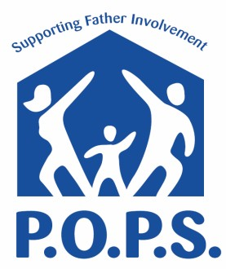
Parent Cafés for DADS

• Want to be more involved with caring for your child? (0-12 years)

• Want to have more balance between family, life, and work?

• Want to have better communication within your family?

• Want to learn more about community resources?

The POPS program covers these topics and more!

Come join us!

Groups forming NOW! Participation is FREE!

When: 8Tuesday Evenings (Starting January 8, 2019)
From 5:30-7:00 PM

Where: CAPSLO HOUSE at 1118 Palm Street, SLO

Snacks provided!
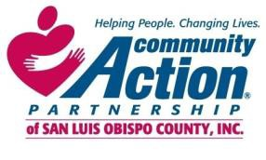

Have questions? Want to register?
Call: Doug Jenison

1-805-544-4355 x209

